[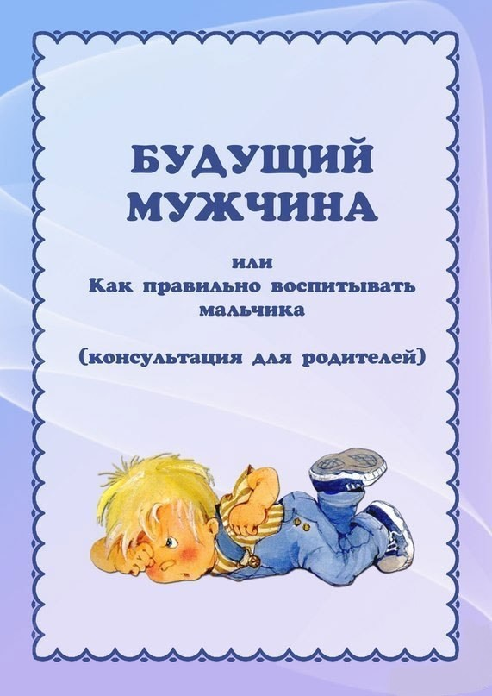](https://ok.ru/dk?cmd=PopLayerPhoto&st.layer.cmd=PopLayerPhotoOuter&st.layer.type=GROUP&st.layer.revNav=off&st.layer.limitedUi=false&st.layer.sphotoIds=865093129239%3B865093128983%3B865093128727%3B865093128471%3B865093128215%3B865093127959%3B865093127703&st.layer.showNav=on&st.layer.photoAlbumId=55318231056407&st.layer.epm=off&st.layer.photoId=865093129239&st.layer.opl=off&st.layer.navStartPhotoId=865093129239&st.layer.sbd=off&st.cmd=userMain&st._aid=GroupTopicLayer_openPhotoLayer)

[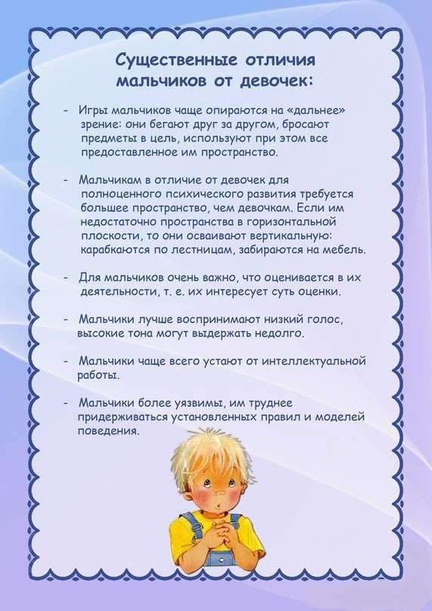](https://ok.ru/dk?cmd=PopLayerPhoto&st.layer.cmd=PopLayerPhotoOuter&st.layer.type=GROUP&st.layer.revNav=off&st.layer.limitedUi=false&st.layer.sphotoIds=865093129239%3B865093128983%3B865093128727%3B865093128471%3B865093128215%3B865093127959%3B865093127703&st.layer.showNav=on&st.layer.photoAlbumId=55318231056407&st.layer.epm=off&st.layer.photoId=865093128983&st.layer.opl=off&st.layer.navStartPhotoId=865093128983&st.layer.sbd=off&st.cmd=userMain&st._aid=GroupTopicLayer_openPhotoLayer)

[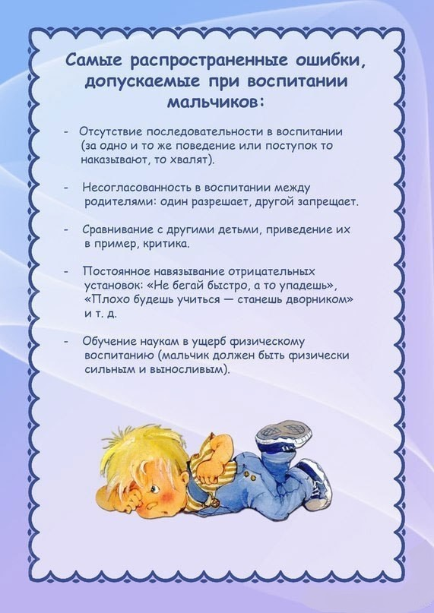](https://ok.ru/dk?cmd=PopLayerPhoto&st.layer.cmd=PopLayerPhotoOuter&st.layer.type=GROUP&st.layer.revNav=off&st.layer.limitedUi=false&st.layer.sphotoIds=865093129239%3B865093128983%3B865093128727%3B865093128471%3B865093128215%3B865093127959%3B865093127703&st.layer.showNav=on&st.layer.photoAlbumId=55318231056407&st.layer.epm=off&st.layer.photoId=865093128727&st.layer.opl=off&st.layer.navStartPhotoId=865093128727&st.layer.sbd=off&st.cmd=userMain&st._aid=GroupTopicLayer_openPhotoLayer)

[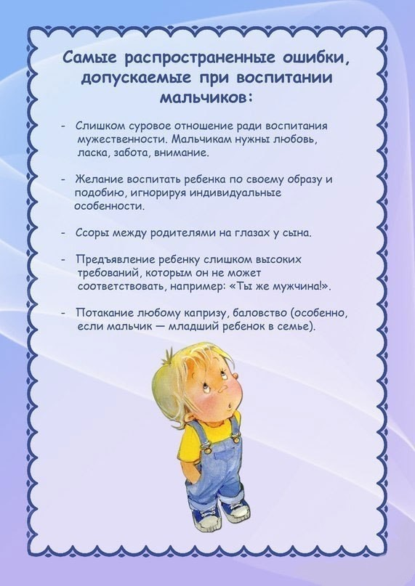](https://ok.ru/dk?cmd=PopLayerPhoto&st.layer.cmd=PopLayerPhotoOuter&st.layer.type=GROUP&st.layer.revNav=off&st.layer.limitedUi=false&st.layer.sphotoIds=865093129239%3B865093128983%3B865093128727%3B865093128471%3B865093128215%3B865093127959%3B865093127703&st.layer.showNav=on&st.layer.photoAlbumId=55318231056407&st.layer.epm=off&st.layer.photoId=865093128471&st.layer.opl=off&st.layer.navStartPhotoId=865093128471&st.layer.sbd=off&st.cmd=userMain&st._aid=GroupTopicLayer_openPhotoLayer)

[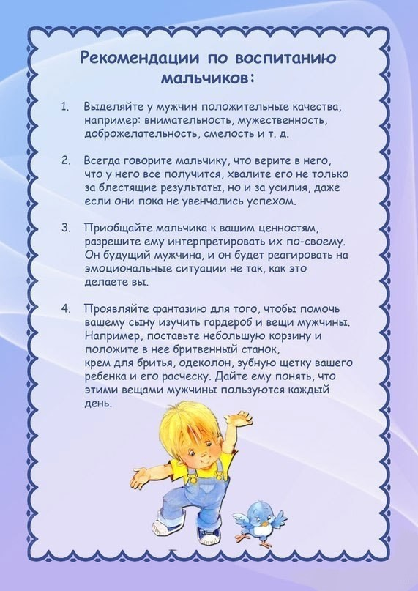](https://ok.ru/dk?cmd=PopLayerPhoto&st.layer.cmd=PopLayerPhotoOuter&st.layer.type=GROUP&st.layer.revNav=off&st.layer.limitedUi=false&st.layer.sphotoIds=865093129239%3B865093128983%3B865093128727%3B865093128471%3B865093128215%3B865093127959%3B865093127703&st.layer.showNav=on&st.layer.photoAlbumId=55318231056407&st.layer.epm=off&st.layer.photoId=865093127959&st.layer.opl=off&st.layer.navStartPhotoId=865093127959&st.layer.sbd=off&st.cmd=userMain&st._aid=GroupTopicLayer_openPhotoLayer)

[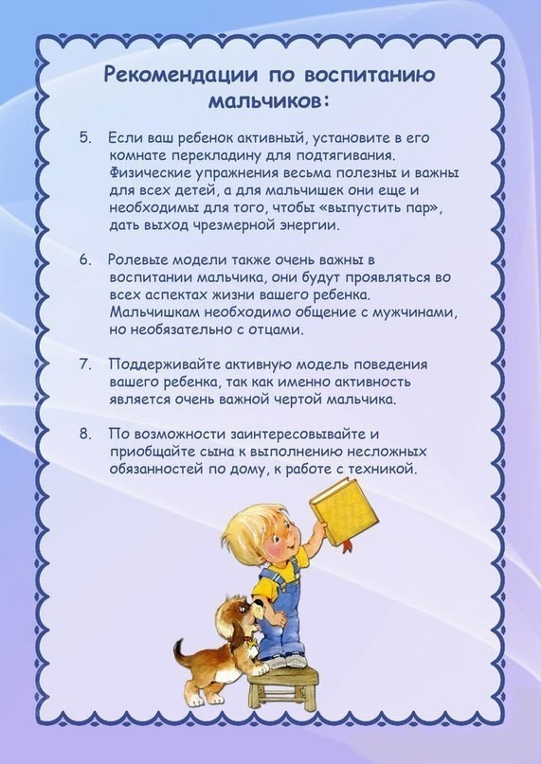](https://ok.ru/dk?cmd=PopLayerPhoto&st.layer.cmd=PopLayerPhotoOuter&st.layer.type=GROUP&st.layer.revNav=off&st.layer.limitedUi=false&st.layer.sphotoIds=865093129239%3B865093128983%3B865093128727%3B865093128471%3B865093128215%3B865093127959%3B865093127703&st.layer.showNav=on&st.layer.photoAlbumId=55318231056407&st.layer.epm=off&st.layer.photoId=865093127703&st.layer.opl=off&st.layer.navStartPhotoId=865093127703&st.layer.sbd=off&st.cmd=userMain&st._aid=GroupTopicLayer_openPhotoLayer)